

JASIAN SON’S COMPANY LTD BUSINESS PLAN
(The Heart of Secure Deliveries)

- EXECUTIVE SUMMARY
The Nairobi Market and shop owners research indicates that there has been a tremendous increase of online buyers, up-to 10000 shipments are on daily basis bought and the same getting to the buyer safely has been a big issue, that’s a whopping 50% of the end up getting lost or too much conman ship involved therein.
JASIAN Deliveries provides a Digitalized, premium, sustainable Product confirmation, pickups and delivery services for both buyers and sellers within and outside Nairobi.
- COMPANY DESCRIPTION
JASIAN Deliveries’ mission is to change the face of our city in terms of online buyers and help the business owners create their outdoor living space of their dreams by building trust within their clients/customers.
Our objectives over the next one year are to:
- Solidify a glowing reputation as a service-based business that always exceeds customers’ expectations and honors the delivery operations.
- That in six months’ time, we can work on a roadmap delivery of at least 2000 shipments daily.
- Maintain a minimum profit for now until we sell out our services in gaining more trust from our customers (2000*200 = 400,000 daily)

- OUR MARKET POTENTIAL.
JASIAN’s ideal customers are all shops selling online and any company that may need a well-organized, secure and system structured delivery provider.
- COMPETITIVE ANALYSIS
So far in our city, we have non that is well structured, secure as what we intend to deploy with JASIAN.

- MARKETING AND SALES STRATEGY
JASIANs’ marketing and sales strategy will leverage, in order of importance:
- Word of mouth (Sales Persons)
- Referrals
- Reviews and ratings
- Local Google Ads
- Social media
- Home shows
- Direct mail

Reputation is the number one purchase influencer in high-end deliveries. As such, channels 1-4 will continue to be our top priority.
Our social media strategy will involve YouTube videos of the pickups & delivery processes as well as multiple Instagram accounts and Pinterest boards showcasing professional structures/ staffs.

- OUR BUSINESS FUNDING REQUEST.

JASIAN being a new business, below is our Start up budget template.
. An Office within CBD area with a small, structured warehouse for sorting and preparations for deliveries according to various destinations.
. 3-6 branded closed Tuktuks for rout delivery.
. We need at least 2-3 motorbikes for shipment collection
. Staffing: 4-6 Drivers/ Riders, 2 clerks,2 ops agents,1 security officer,1 brand and sales rep & 1 accountant.
. Server, Barcodes, Scanners, Website/Ops Management System Software:
. Miscellaneous KSH 500,000.
TOTAL OF KSH 3,500,000.
NOTE
For a start, our target of delivering 1000 shipments daily, we are looking at making a profit of KES 200,000 daily, KES 1,200,000 weekly, KES 4,800,000 Monthly and KES 57,600,000 Yearly.

- ORGANIZATION AND MANAGEMENT
. Francis Mwita, Founder & CEO
. , Shareholder
. Heads of Finance/ Operations/ IT/Sales/CS
- APPENDIX
All legal documentations attached
- Deeds, local permits, and legal documents
- Certifications that bolster your credibility
- Business registries and professional licenses pertaining to your legal structure or type of business

- Our Policies and Standards
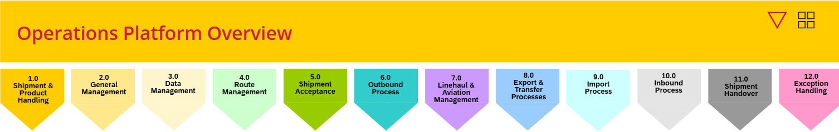
JASIAN’S CHECKPOINT SCANS
  - Collection scan PU- Shipment picked up - done when we collect the shipment from the shop owner. This point, the buyer/Shop owner can Truck/Trace the shipment using our Trucking No.
  - Warehouse scan WS- Warehouse Sorting- Meaning the shipment is in our facility and its being sorted according to routing.
  - Vehicle Load scan LV- Load Vehicle- Meaning, the shipment is ready for dispatch to owner (Buyer)
  - An Okay scan OK- this point, the shipment has been received by the owner and same has been signed.

